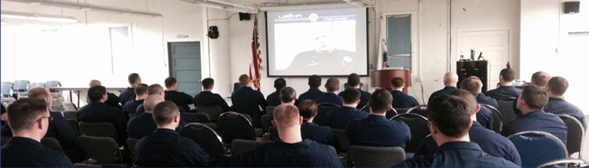
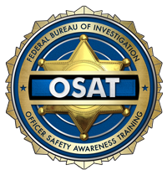
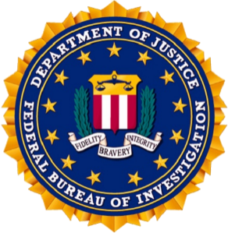
U. S. Department of Justice
Federal Bureau of Investigation
Officer Safety Awareness Training

A close look at why our nation’s law enforcement professionals are being assaulted and killed feloniously or accidentally, with a focus on prevention.
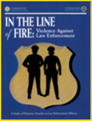
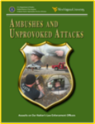
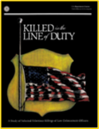
Officer and Offender Perceptions
Training
Foot Pursuits
Drawn Gun
Arrest Situations and Handcuffing
“Is Today Your Day?”
Ambushes and Unprovoked Attacks
Street Combat Veterans
Traffic Stops
Will to Win and Will to Survive
The Deadly Mix and Conclusion
Officer & Offender Perceptions
Training
Foot Pursuits
Drawn Gun
Arrest Situations & Handcuffing
“Is Today Your Day”
Ambushes and Unprovoked Attacks
Street Combat Veterans
Traffic Stops
Will to Win & Will to Survive
The Deadly Mix & Conclusion

“Providing law enforcement with perspective for a safer tomorrow.”
Date: May 7th, 2024 Time: 0800 - 1700
Location: Department of Corrections Training Academy
515 E. Dahlia Ave, Ste 200, Palmer, AK 99645
POC info: Rachel Lords, Rachel.lords@alaska.gov, 907 761-5641

Criminal Justice
Information Services
(CJIS) Division
1000 Custer Hollow Road
Clarksburg, WV 26306
https://www.fbi.gov/services/cjis

